**SECTION A (60 Marks)**

Answer only **three** questions from this section.

1. An organic compound, T contains **60.00% carbon**, **13.30% hydrogen** and the **rest being oxygen**. When **0.23g** of an organic compound, T was vaporized at a temperature of **29ᵒC** and a pressure of **90.2mmHg**, it occupied a volume of **800cm3**.
2. Determine the:
3. The empirical formula of an organic compound, T. (02 marks)
4. The molecular formula of an organic compound, T. (03 marks)
5. An organic compound, T reacts with phosphorous pentachloride at room temperature to produce white fumes.
6. Name the functional group in an organic compound, T. (01 mark)
7. Write the structural formulae and IUPAC names of all the possible isomers of an organic compound, T. (02 marks)
8. An organic compound, T reacts with a solution of concentrated hydrochloric acid and anhydrous zinc chloride to form a cloudy solution after **8 minutes**.
9. Identify an organic compound, T. (0½ mark)
10. Explain why a cloudy solution is formed. (01½ marks)
11. Write a mechanism for the reaction between an organic compound, T and concentrated hydrochloric acid. (02 marks)
12. Describe how an organic compound, T can be:
13. Prepared from 2,2-dibromopropane. (04 marks)
14. Converted to butanoic acid. (04 marks)

[Equation(s) are not required]

1. (a).State Kohlrauch’s law of independent migration of ions. (01 mark)
2. At **298K**,a solution containing **2.84g per litre** of anhydrous sodium sulphate has an electrolytic conductivity of **5.196 X 10-3Ω1cm1**. Determine the:
3. Molar conductivity of sodium sulphate solution. (03 marks)
4. Molar conductivity of sodium ions in the solution. [The molar conductivity sulphate ions is **159.6Ω-1cm2mol-1** at **298K**] (02 marks)
5. (i).Draw a **sketch graph** to show how molar conductivity of sodium sulphate varies with the square root of concentration. (02 marks)

(ii).Explain the **shape of the graph** you have sketched in (c) (i). (03 marks)

1. The table shows the molar conductivity of bromoethanoic acid at different concentrations.

|  |  |  |  |  |
| --- | --- | --- | --- | --- |
| Concentration (mol/dm3) | 0 | 0.004 | 0.020 | 0.200 |
| Molar conductivity (Ω-1cm-2/mol) | 411 | 55 | 18 | 7 |

1. Explain the trend in the molar conductivity of bromoethanoic acid. (02 marks)
2. Calculate the **degree of ionization** of bromoethanoic acid at the dilution of **50/moldm3**. (02½ marks)
3. Determine the **pH** and hence the **ionization constant, Ka** of the acid in (d) (ii) above. (04½ marks)
4. Fluorine, chlorine, bromine and iodine are elements of (VII) of the periodic table.
5. Write the formulae of the hydrides of the elements. (02 marks)
6. The table below shows the boiling points of the hydrides of the above elements.

|  |  |  |  |  |
| --- | --- | --- | --- | --- |
| Hydrides | F | Cl | Br | I |
| Boiling point (ᵒC) | +19.9 | -85.0 | -66.7 | -35.4 |

1. Explain the trend of boiling points of the hydrides of the above elements. (04 marks)
2. State two other properties in which the hydride of fluorine differs from hydrides of other group (VII) elements. (02 marks)
3. Describe the reaction of the hydrides of the above elements with:
4. Concentrated sulphuric acid. (05½ marks)
5. Potassium carbonate. (02½ marks)
6. Describe the preparation of chlorine on a large scale.[Diagram not required] (04 marks)
7. State what is meant by the terms **activation energy** and **order**  **of reaction**. (02 marks)

(b) Ethanal decomposes when heated according to the following equation below.



Caculate the **enthalpy** of decomposition of ethanol. [The standard enthalpies of combustion of ethanal, methane and carbon mononoxide are **-1,187, -884** & **-283.5KJ/mol** respectively] (03 marks)

1. The energy of activation for the catalyzed and uncatalysed decomposition of ethanal are **136** and **190KJ/mol** respectively.
2. Draw the reaction profile using the same axes for the catalyzed and uncatalysed reactions. Indicate the values of activation energy and heat change. (04 marks)
3. Explain how a catalyst increase the rate of decomposition of ethanal. (02 marks)
4. The rate equation for reaction.



Rate = K[S2O32-][H+]2

1. Deduce how the rate will be affected when the concentrations of the reactants are tripled. (02 marks)
2. Describe an experiment to determine the order of the reaction with respect to thiosulphate ions in the laboratory. (07 marks)

**SECTION B (40 Marks)**

Answer only **two** questions from this section.

1. Complete the following equations and outline the possible mechanism for the reaction in each case.



1. The atomic numbers of calcium and chromium are 20 & 24 respectively.
2. Write the electronic configuration of the atom of each element. (02 marks)
3. (i) State three properties in which chromium differ from calcium. (01½ marks)
4. Explain why chromium has higher melting points than calcium. (02 marks)
5. Describe the reaction of chromium with:
6. Water. (02½ marks)
7. Sulphuric acid. (04 marks)
8. Explain the reactions that take place when chromium (III) sulphate solution is treated with:
9. Potassium sulphite solution. (04 marks)
10. Excess concentrated ammonia solution. (04 marks)
11. Steam distillation is one of the methods used in purification below their boiling points.
12. (i) State three requirements for purifying a substance by steam distillation.(01½ marks)
13. Explain the principle of purifying a substance by steam distillation method. (03 marks)
14. Cyclohexane distills on steam at a temperature of **98ᵒC** and a standard pressure of **760mmHg**.Calculate the percentage of cyclohexane in the distillate.[The vapour pressure of water is **655mmHg** at the same temperature](03 marks)
15. Nitric acid and water form non-ideal solution that deviates from Raoult’s law. The table below shows the composition of nitric acid in liquid and vapour phases at different temperatures.

|  |  |  |  |  |  |  |  |  |  |  |  |  |  |
| --- | --- | --- | --- | --- | --- | --- | --- | --- | --- | --- | --- | --- | --- |
| Temperature (ᵒC) | | 90 | 96 | 101 | 103 | 104 | 106 | 110 | 113 | 116 | 119 | 120 | 121 |
| %age of HNO3 | Liquid | 93 | 85 | 09 | 18 | 78 | 30 | 43 | 71 | 59 | 66 | 67 | 68 |
| Vapour | 98 | 96 | 01 | 03 | 90 | 08 | 20 | 81 | 40 | 53 | 58 | 68 |

1. Plot a well-labelled boiling point composition diagram for the nitric acid-water system. [The boiling points of nitric acid and water are **86ᵒC** and **100ᵒC** respectively. (05 marks)
2. Explain why the mixture of nitric acid and water shows the type of deviation in the diagram in (i) above. (04 marks)
3. Describe what happens when a liquid mixture containing 40% of nitric acid is fractionally distilled. (03½ marks)
4. Explain the following observations.
5. A mixture of **50cm3** of **0.1M** ammonium hydroxide solution and **50cm3** of **0.1M** hydrochloric acid gives a resultant solution whose pH is less than **7**. (04½ marks)
6. The solubility of lithium chloride in ethanol is higher than the solubility of potassium chloride in ethanol. (03 marks)
7. When iodine crystals are added to cold dilute sodium hydroxide solution, a grey solid dissolves to a pale yellow solution which turns colourless on standing. (04 marks)
8. When carbon dioxide gas was bubbled through an aqueous solution of potassium manganate (VII) solution, the green solution turns purple and a black precipitate is formed. (04 marks)
9. When methanoic acid was warmed with Fehling’s solution, a red precipitate is formed while ethanoic acid, No observable change occurs.

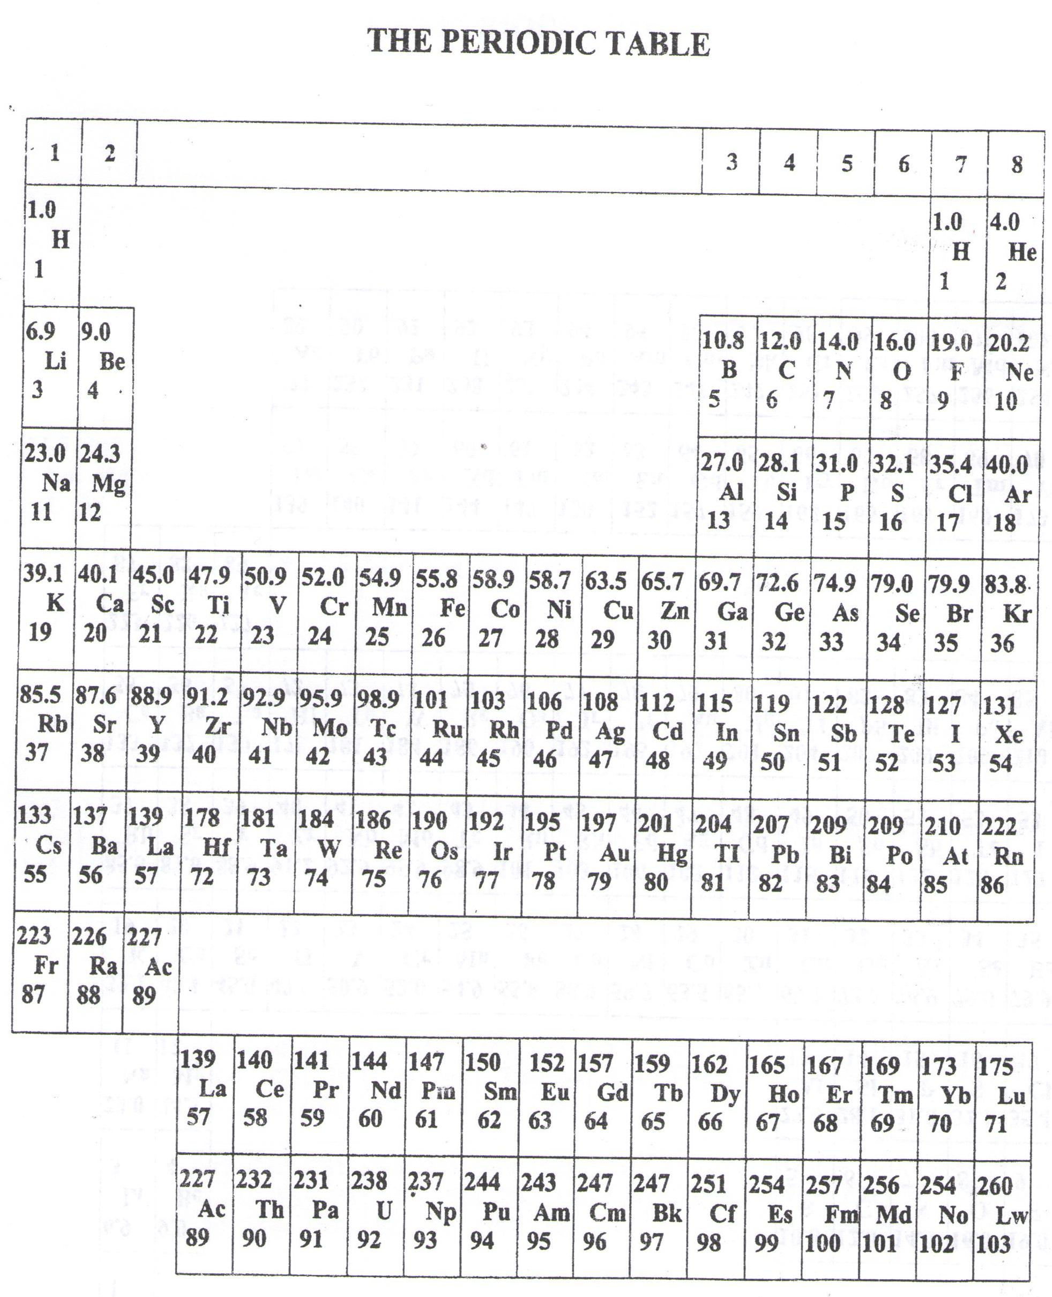

* ===END===

WELCOME TO SENIOR SIX, YEAR 2023

This is the last page of the printed paper, Page 07